**SRM INSTITUTE OF SCIENCE & TECHNOLOGY**

Ramapuram Campus, Chennai - 600 089.

Faculty of Engineering and Technology

Department of Computer Science and Engineering

**Climate Change Exploration**

## **Team Members:**

S.A.Bhanu Teja RA1911027020031

## **Objective:**

Climate change is one of the most fiercely debated scientific issues of the past 20 years. Human-induced warming is superimposed on a naturally varying climate, the temperature rise has not been, and will not be, uniform or smooth across the country or over time.

Climate change fatalities are generally linked to four different catalysts:

* Rising temperatures
* Declining air quality
* Extreme weather
* Vector-borne illnesses

In this project we are concentrating on the reason for Rising Temperature. For which, we have taken climate change data to visualize the temperature variation through Exploratory Data Analysis using R & R studio.

## 

## **Dataset URL**

* <https://www.kaggle.com/vageeshabudanur/riseintemp-dataset>

## **Dataset Description**

The file *climate_change.csv* contains climate data from May 1983 to December 2008. The available variables include:

* **Year**: the observation year,
* **Month**: the observation month,
* **MEI**: multivariate El Nino Southern Oscillation index (MEI), a measure of the strength of the El Nino/La Nina-Southern Oscillation (a weather effect in the Pacific Ocean that affects global temperatures),
* **CO2**: atmospheric concentrations of carbon dioxide,
* **CH4**: atmospheric concentrations of methane,
* **N2O**: atmospheric concentrations of nitrous oxide,
* **CFC-11**: atmospheric concentrations of trichlorofluoromethane,
* **CFC-12**: atmospheric concentrations of dichlorodifluoromethane,
* **TSI**: the total solar irradiance (TSI) in W/m2 (the rate at which the sun’s energy is deposited per unit area). Due to sunspots and other solar phenomena, the amount of energy that is given off by the sun varies substantially with time,
* **Aerosols**: the mean stratospheric aerosol optical depth at 550 nm. This variable is linked to volcanoes, as volcanic eruptions result in new particles being added to the atmosphere, which affect how much of the sun’s energy is reflected back into space,
* **Temp**: the difference in degrees Celsius between the average global temperature in that period and a reference value.

Here *CO*2CO2, *N*2*O*N2O and *CH*4are expressed in ppmv (parts per million by volume – i.e., 397 ppmv of CO2 means that *CO*2 constitutes 397 millionths of the total volume of the atmosphere). CFC.11 and CFC.12 are expressed in ppbv (parts per billion by volume).

Before cleaning and analyzing the data set we will include some libraries that are needed in R Markdown.

where

**dplyr** provides a set of tools for efficiently manipulating datasets in R, it focuses on data frames.

**ggplot2** is a data visualization package.

**plotly** provides online graphing, analytics, and statistics tools for individuals and collaboration, as well as scientific graphing libraries.

**RColorBrewer** package has a variety of sequential, divergent and qualitative palettes that has color palettes.

## **Data Exploration Code & ScreenShots**

| # Read climate_change.csv file and view the dataset stored in climate_change variable > library(readr)  > climate_change <- read_csv("~/Documents/climate_change_data_science/climate_change.csv")  > View(climate_change) |
| --- |

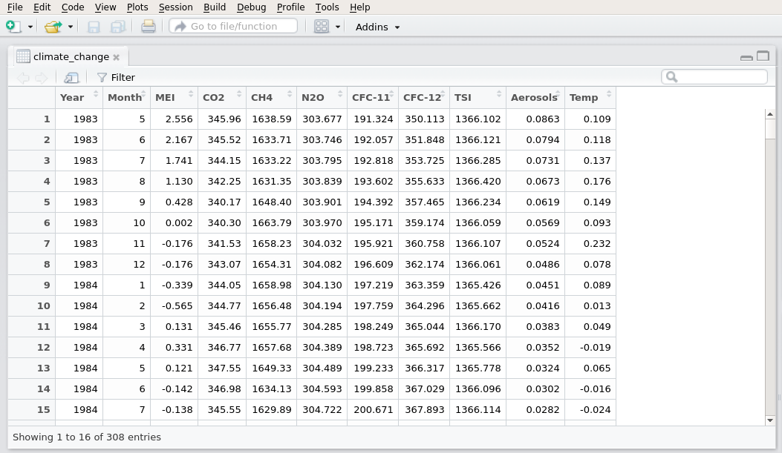

#### Screenshot 1: import and View climate_change.csv File

| # To see the structure and dimension of the data set using the command > str(climate_change)  > dim(climate_change) |
| --- |

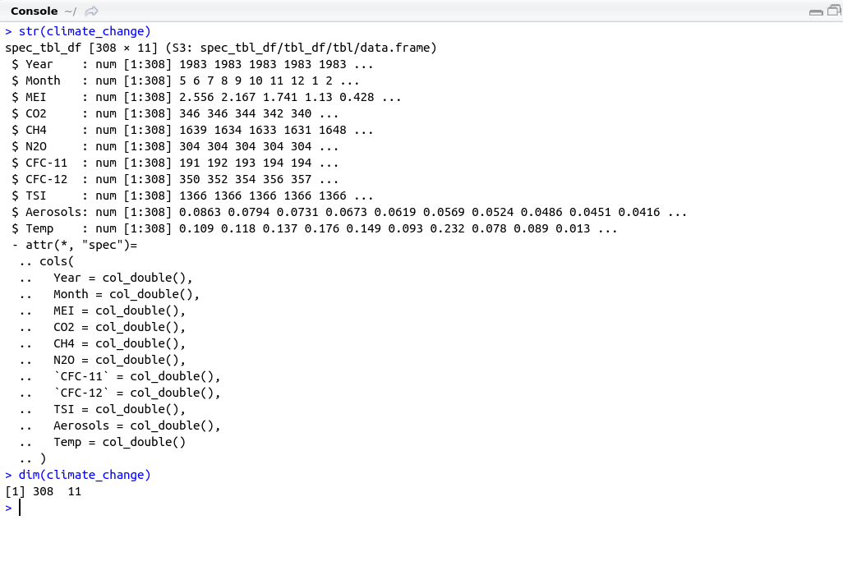

#### Screenshot 2 : structure and dimension of the data set

| # Change Months data from numeric to String > climate_change$Month[climate_change$Month == 1]<- "Jan"  > climate_change$Month[climate_change$Month == 2]<- "Feb"  > climate_change$Month[climate_change$Month == 3]<- "March"  > climate_change$Month[climate_change$Month == 4]<- "April"  > climate_change$Month[climate_change$Month == 5]<- "May"  > climate_change$Month[climate_change$Month == 6]<- "June"  > climate_change$Month[climate_change$Month == 7]<- "July"  > climate_change$Month[climate_change$Month == 8]<- "Aug"  > climate_change$Month[climate_change$Month == 9]<- "Sep"  > climate_change$Month[climate_change$Month == 10]<- "Oct"  > climate_change$Month[climate_change$Month == 11]<- "Nov"  > climate_change$Month[climate_change$Month == 12]<- "Dec" |
| --- |

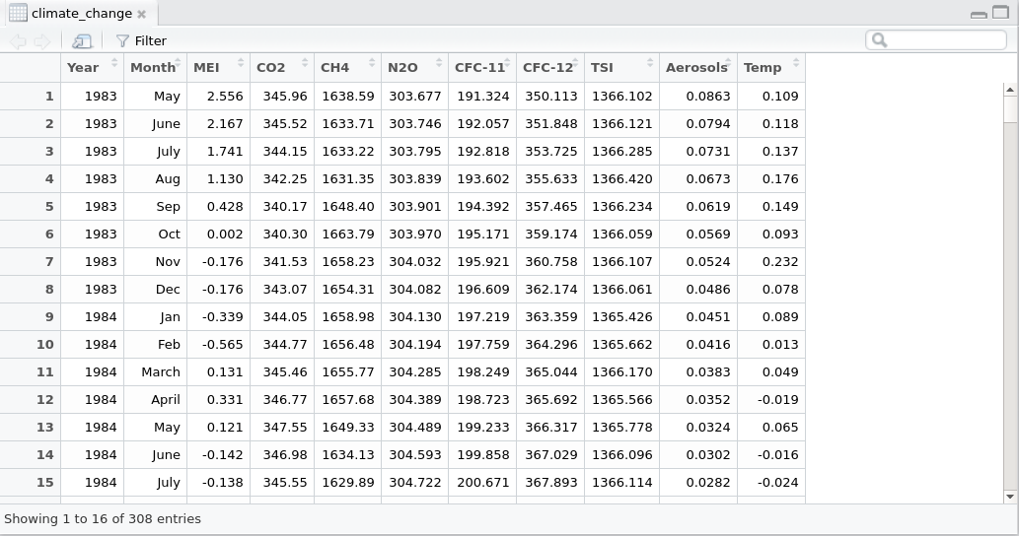

#### Screenshot 3 : Change Months data from numeric to String

| # Install and Include Libraries > library(dplyr)  > library(ggplot2)  > library(plotly)  > library("RColorBrewer")  > library(lubridate) # Create a new data set without missing data. > new_climate_change <- na.omit(climate_change) # look at the dimension of the new data frame.. > dim(new_climate_change) |
| --- |

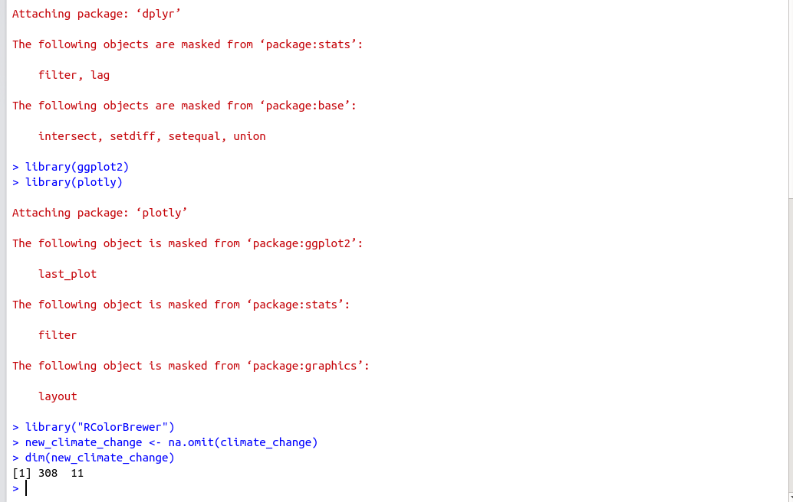

#### Screenshot 4 : Import library and create new dataset variable

| # Creating Barplot Temperature per year for particular gases > climate_change_chart <- ggplot(climate_change, aes(x = Year, y = Temp, fill = CO2)) +  xlab("Year") +  ylab("Temperature") +  theme_minimal(base_size = 14)  > barplot <- climate_change_chart +  geom_bar( position = "dodge", stat = "identity",color= "white")  ggplotly(barplot) |
| --- |

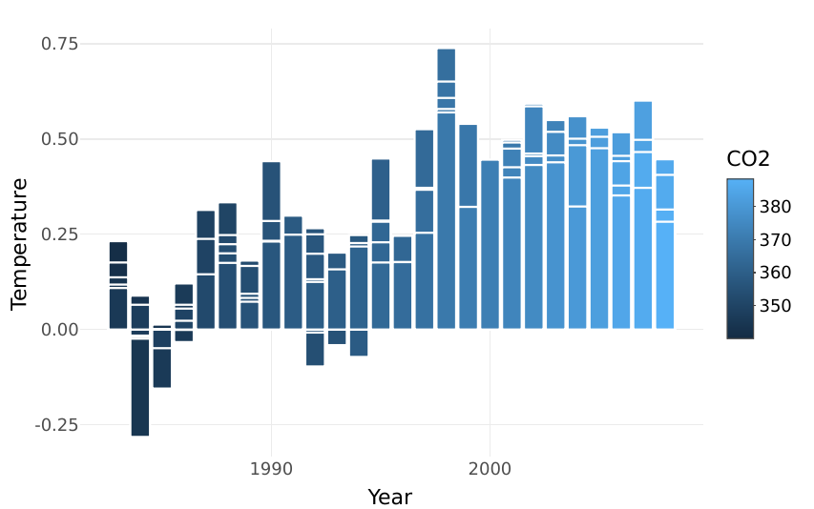

#### Screenshot 5 : Barplot for CO2

| # adding Year-Month variable as date climate_change_ymd <- climate_change %>%  mutate(year_month = ymd(paste(climate_change$Year, climate_change$Month, truncated = 1)))  L1 <- ggplot(climate_change_ymd, aes(year_month, Temp)) +  geom_line() +  geom_smooth(se=FALSE, linetype = "dotted") +  labs(title = "Temperature (1983-2008)",  x = "Year",  y = "Temperature") +  theme(plot.title = element_text(hjust = 0.5))  ggplotly(L1) |
| --- |

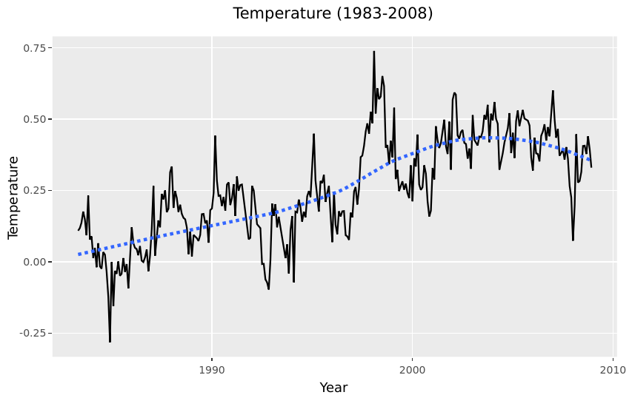

#### Screenshot 6 : Line-plot between Temperature and Year

| # Temperature Month-wise plot for each year in data Tg <- ggplot(climate_change, aes(as.factor(Month), Temp)) +  geom_point(aes(color = as.factor(Year))) +  geom_line(aes(group = as.factor(Year),  color = as.factor(Year)),  alpha = 0.7) +  labs(title = 'Temperature by month') +  xlab("Months") +  ylab("Temperature") +  theme(axis.text.x = element_text(size = 6,angle = 90,hjust = 0.5, vjust = 0.5))  # theme(legend.position = "none")  ggplotly(Tg) |
| --- |

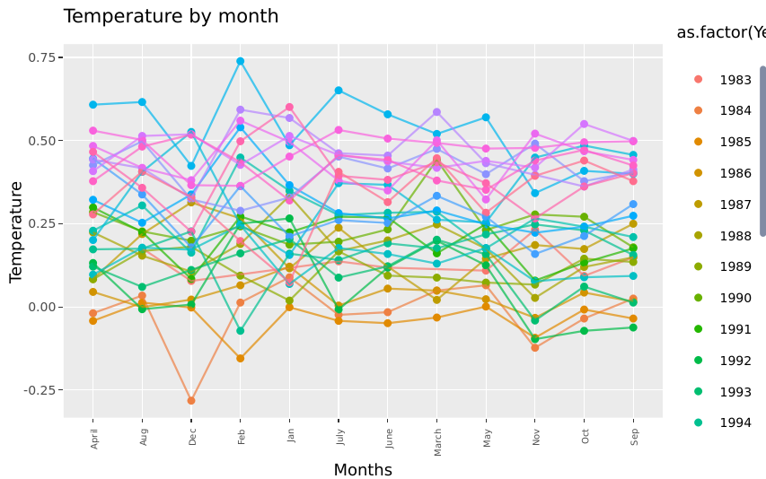

#### Screenshot 7 : Line-plots between Temperature and Year(in months)

| #Temperature-density distribution  library(ggridges)  ggplot(climate_change, aes(x = Temp, y = as.factor(Year))) +  geom_density_ridges_gradient(aes(fill = ..x..),  scale = 3, size = 0.3, alpha = 0.5) +  scale_fill_gradientn(colours = c("#0D0887FF", "#CC4678FF", "#F0F921FF"),  name = "Temp") +  labs(title = 'Temperature density') +  theme(legend.position = c(0.9,0.2)) +  xlab("Temperature") +  ylab("Year")+theme_minimal(base_size = 10) |
| --- |

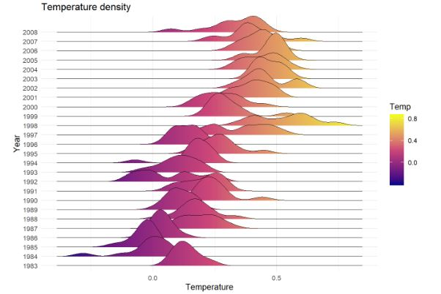

| #par(mfrow=c(2,2))scat_plot1 <- ggplot(climate_change_ymd, aes(year_month, CO2))+geom_line(colour="blueviolet")+geom_smooth(method = "lm")+ggtitle("Carbon Dioxide")scat_plot2<- ggplot(climate_change_ymd, aes(year_month, N2O))+geom_line()+geom_smooth(method = "lm")+ggtitle("Nitrous Oxide")scat_plot3<- ggplot(climate_change_ymd, aes(year_month, CH4))+geom_line(colour="springgreen4")+geom_smooth(method = "lm")+ggtitle("Methane")scat_plot4 <- ggplot(climate_change_ymd, aes(year_month, MEI))+geom_line(colour="mediumorchid4")+ggtitle("MEI")grapgh_arrange<-ggarrange(scat_plot1, scat_plot2, scat_plot3, scat_plot4 + rremove("x.text"), labels = c("A", "B", "C", "D"), ncol = 2, nrow = 2)annotate_figure(grapgh_arrange, top = text_grob("Vartations of CO_2, N2O, CH4 and MEI by year", color = "red", face = "bold", size = 14)) |
| --- |

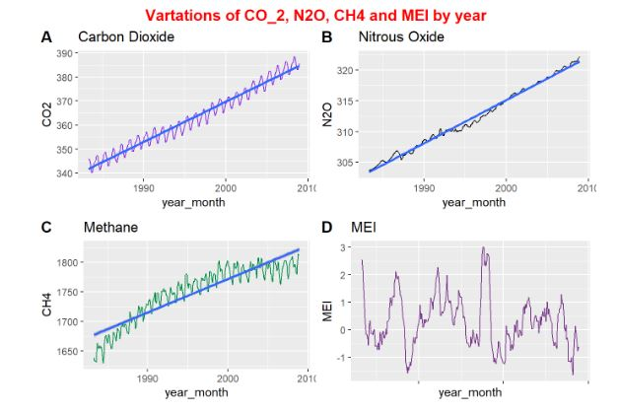

| #LINEAR REGRESSION MODELfit=lm(Temp~CO2,data=climate_change)summary(fit)climate_multreg <- filter(climate_change, Month == "Jan" | Month == "Feb")fit1=lm(Temp~Year+Month,data=climate_multreg)summary(fit1)ggPredict(fit1,se=TRUE, interactive=TRUE) |
| --- |

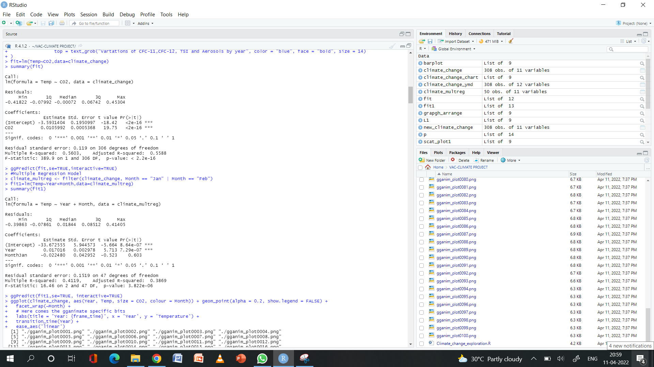

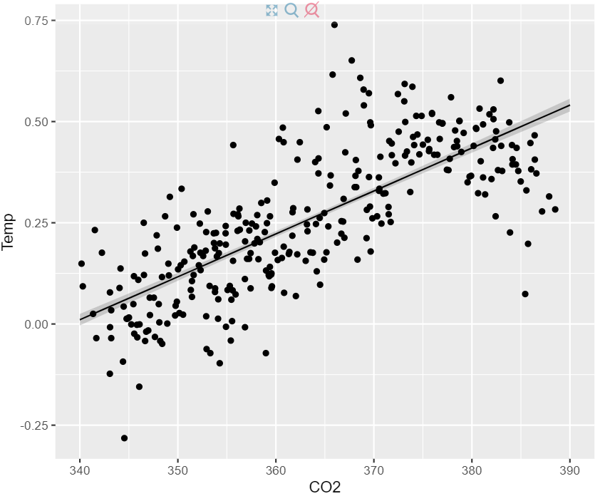

| #Multiple Regression Modelclimate_multreg <- filter(climate_change, Month == "Jan" | Month == "Feb")fit1=lm(Temp~Year+Month,data=climate_multreg)summary(fit1)ggPredict(fit1,se=TRUE, interactive=TRUE) |
| --- |

